**PARTY OF THE EUROPEAN LEFT**



**AGENDA**

***ENCUENTRO***

**EUROPEAN LEFT – LATIN AMERICA**

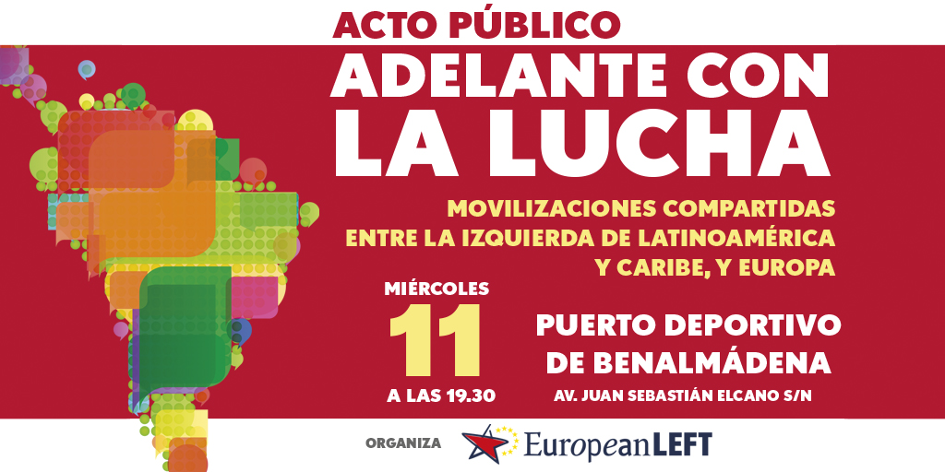

**Thursday,12 DEC**

**10am – 1pm** Debate on the current situation in Latin America and Caribbean with guests

* *Las 13 Rosas*

**6th CONGRESS OF THE**

**PARTY OF THE EUROPEAN LEFT**

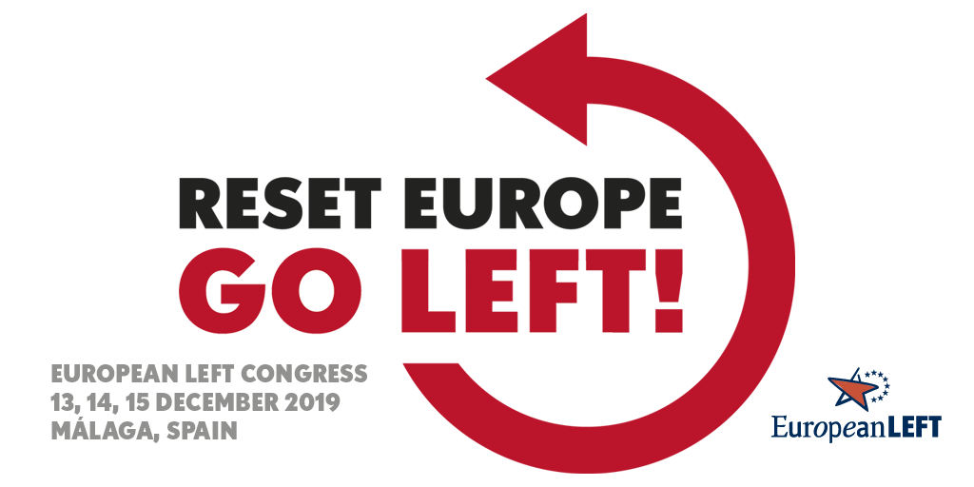

**EVENT LOCATION**

Hotel Alay

Av. Alay, 5

29630 Benalmádena, Málaga, Spain

**Friday 13 DEC**

**12am – 2pm** Women’s Meeting – *Las13 Rosas  
 interpretation EN – FR- ES*

**2pm** Registration**–** *Hall*

**EL CONGRESS**

*interpretation EN – FR – DE – ES – RU*

* *Dolores Ibarruri*

**4pm Opening**

Welcome by Host parties

Presentation EL delegates and international guests

Greeting Local Authorities

National and International Guests

Presentation voting system

Presentation Rules of Procedure

Adoption Rules of Procedure

Intervention of Trade Unions

Presentation Political Document

Presentation Evaluation & Evolution

Presentation Answers to Working Groups’ Questionnaire

Balance and Perspectives of the European Forum

Debate on the Political Document and Evaluation & Evolution

Intervention of EL President, Gregor Gysi

**9pm** Dinner

**10pm** Council of Chairpersons *–* *Dolores Ibarruri*

*interpretation EN – FR – DE – ES*

Motions Commission,[1] *-* *Marielle Franco*

*interpretation EN – FR*

Political Document [2] – *Las 13 Rosas*

*interpretation EN – FR*

Evaluation & Evolution[3] *–* *Rosa Luxemburg*

*interpretation EN – FR*

Statutes[4] *-* *Simone de Beauvoir*

*interpretation EN – FR*

**Movie** - ES : « La huella de la desbandà » - *Hypatia*

( Production Club Senderista La Desbandà and Eterea Visual  
with the support of the European Left )

**Saturday 14 DEC**

**9am** Intervention of Delegations

Report of Treasurer

Intervention of Delegations

National and international Guests

Intervention on the women’s meeting

**2pm** Lunch

**3.30pm** Intervention of Delegations

Speech of the General Secretary of *Sortu*, latest party joining the EL

Report Statutes

Adoption Statutes

Election president Statutes Commission

Intervention of Delegations

Coffee Break

Adoption of Political Document

Report of Auditors

Adoption of Auditors report

Election of Audit group

**9pm** Dinner

**9.45pm** Transform! Cocktail and Concert by Lucia Socam

**Sunday 15 DEC**

**9am** Adoption of motions

- Presentation Documents of working groups

- Others

National and international Guests

Adoption of Evaluation & Evolution document

Election new EL Presidency

Adoption and Presentation of new Executive Board and Treasurer

**12.30pm** **Closing**

By the New EL Presidency

***

**1pm– 2pm** Meeting of new EL Executive Board *-* *RosaLuxemburg*

*interpretation EN – FR - ES*

1. If necessary
2. If necessary
3. If necessary
4. If necessary